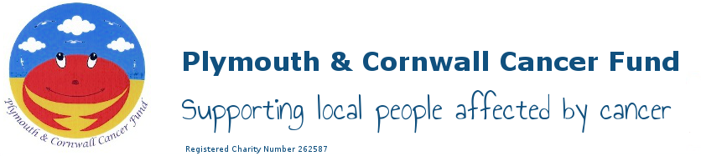

Fundraising Policy

Fundraising Events – Sponsorship

To support Fundraisers participating in Events with the intention of raising money for PCCF, the charity will provide:

- Sponsorship Forms, details of using JustGiving.com, collecting tins, Information leaflets
- At the discretion of the Fundraising Manager, PCCF promotional T shirts/vests where significant amounts are likely to be raised ie. To ensure cost of the item is covered
- Advertising event on PCCF website, Twitter and Facebook
- Where an Event Registration Fee is required (less than £40), the option to reimburse those adults who raise in excess of £100 and children £50. This will be refunded at the point where the donation is made to PCCF. Where the registration fee is in excess of £40, reimbursement of the fee will be considered by PCCF Officers.

Just Giving

Just Giving is an on line fundraising tool for fundraisers and charities to maximise sponsorship, collect donations and gift aid from HMRC.

2017/18: Payment fees are £15/month + vat, 5% fee on donations (plus card fees for credit card 1.3%; paypal 1.45%; Debit card 17p
Donations are sent regularly (weekly), and gift aid is invoiced separately, minus any just giving fees (5%) and card charges

Gift Aid

Donations eligible for Gift Aid will be collected from HMRC by PCCF Treasurer

Approval Date: 27.03.18 (Committee Meeting Minute Nº 1429 )
Review Date: March 2021

